6 Way Horizontal Mounted Rackmount PDU - UK Sockets (PDU-6WS-H)

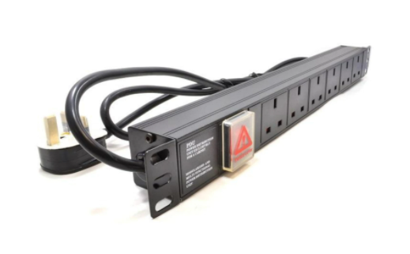

Description:

The LMS Power PDU-6WS-H is a high-quality 19-inch Rackmount PDU (Power Distribution Unit) that simply fits within the universal horizontal mounting brackets of data, telecom and server cabinets.
A critical accessory for your data cabinets if you need to provide effective power to devices including Ethernet Switches, Servers, UPS, NAS and of course cabinet accessories including cooling fan trays.
Robust, alloy design complete with rackmount brackets fitted, high-quality Neon Switch and of course UK output sockets together with a high quality, BSI-fitted
13 Amp UK plug.

Key Features:

Standard UK 3-Pin power outlets for your appliances
1U high means the PDU can fit into the smallest cabinet
Neon On/Off Rocker switch to prevent accidental turn off
Backed up by LMS Power's exclusive 3-year warranty

Applications:
Create instant power feeds to your data, telecom or server cabinets
Provide effective power for cabinet cooling fans, UPS systems
Ideal as stand-alone trailing sockets outside the cabinet

Product Code:
Part Number: PDU-6WS-H
EAN: 8400800038456
Weight: 1.1Kg approx.

Technical Specifications:
Warranty LMS Data 3-Year Warranty
Chassis 1U 19-inch with mounting brackets
Output Sockets 6 UK 3-PIN Sockets
Power Input Fitted UK 3PIN BSI Plug 13 Amp
Flex Length 1.8 metres (approx)
Power Control On/Off Rocker Switch (illuminated)
Power Rating 4000 Watts (approx)

Supplied With:
PDU-6WS-H 6 Way Horizontal PDU
19-inch cabinet brackets (Fitted)
* Specifications and product design are subject to change. E&OE.

Need a competitively priced but quality Power Distribution Unit (PDU) for your applications or installation? The new PDU-6WS-H is a robust, non-surged protected PDU which features effective electrical distribution to its integral, 6-way, UK-socketed 3-pin sockets. Combining a fully certified UK plug input combined with a compatible heavy load power flex means you can be assured this LMS Data PDU can work without problems, 24/7. Ideal for data, telco and broadcast applications, with the added benefit of a low-profile, 1U hight and the ability to be attached to standard, 19-inch ETSI uprights from popular cabinet and enclosure vendors. Robust in design, with an integral neon illuminated rocker switch for assured functionality, the LMS Data PDU is designed to deliver maximum electrical power - today and tomorrow.

specifications:
Horizontal, high-density Power Distribution Unit (PDU)
UK-plug style plug power input
6-Way UK, 3-Pin Power Outlets
Robust, black aluminium design for industrial use
Neon on/off power switch for assured control
Maximum power rating - 4000W (approx.)
1.8 metre (approx.) power cordage
Ideal for data, telecom, broadcast and HVAC applications

